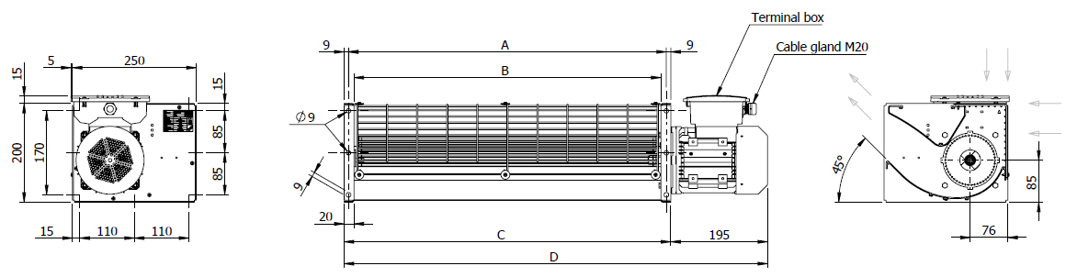**________ *Dimensions***



**________ *Performance Data***

