**________ *Dimensions***

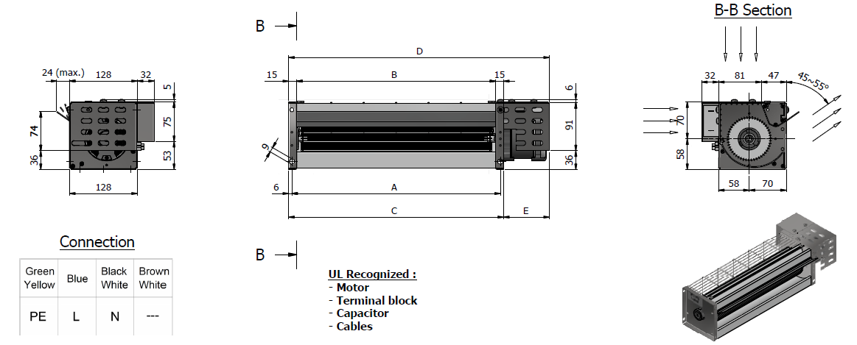



**________ *Performance Data***

